# Week 13 assignment – usability test

Linfang yang

Wednesday 6:30-8 W209

## Background

Our project, “Neural Networks – The good, the bad and the math” is building a website for beginner to learn about and interact with neural networks. Website link: <http://machinelearningalgorithmsillustrated.azurewebsites.net/>

## Task List

Since our website is publically available to anyone, and it is under constructions, we built a task list to solicit user feedbacks about our site, and see how they interact with it, where can we make improvements etc.

We consolidated our task list into a survey with 21 questions, targeting different parts of our website (home page, learn page, play page, math page, and overall site experience). Here is the link to the survey <https://berkeley.qualtrics.com/jfe/form/SV_8odiD2hhiltQfvT>

To see details about the questions, see appendix at the end of this document.

## Participants

User 1 does not have much machine learning background, with basic math knowledge such as function, input, linear. But does not have any knowledge about logistic regression, concept of feature, loss, decision boundary.

User 2 is software engineer, with some knowledge about machine learning basic concept, but does not know much about math.

### Findings:

For user who does not know machine learning basic concepts, they are completely lost, and didn’t know what to do. I had to explain in person and explain in simple words, such as this chart with a slop line is showing how wrong the trained “brain” (model) is. And those black and white dots representing person’s weights and heights. This red line “smartly” finds the right parameters (in terms of ax+b=y) and separates the black dots and white dots.

For user with some machine learning background, they can understand the concept, but since the text were not obvious, they skip text and only look at chart and clicking on buttons, I had to ask them to read text in person and point at things they need to read.

### Home page:

Both read the title, and skipped the explaining text and started clicking on learn or play button. I had to ask them to read those texts. They ready works like “LR” and “NN” and looking confused. They didn’t know what LR or NN mean, they didn’t even know what model mean. I had to explain to them in person.

#### To do: add explanation for math terms. Use simple and graphical words.

### Learn page:

User 1 saw YouTube video and directly clicked on it. The video helps. They both didn’t read the text until I asked them to. They looked at the charts and didn’t know where to click, they tried to double click on the chart and try clicking on things they feel like clickable. They both found the play button after all, but didn’t know what the charts mean. I had to explain to them again. They didn’t know what is a node, and I had to explain to the how neural network came from, and explain how neuron works biologically and how node represent a neuron and what is activation between neurons. Then they understand the node charts on the left. Then I had to explain in person again what is weight. I told them it’s the number of the lines. Node 1 gets to the second node by multiplying the number on the line. Then they get it. When they look at the weight chart, they didn’t know the purple boxes are the weights, I had to again tell them, each box represents a number on the line. Then they get it.

#### To do: reduce technical terms to minimal, and use simple works. Instead of saying weights, just say a number used to multiply. Instead of saying losses, just say a measure for how wrong the prediction is. Then people understand. Need to add label to charts, need to make text more readable and gets people’s attention.

### Play page:

Again, both user didn’t read, the looked at the digit pictures directly then ask me what to do. I explained what is MNIST dataset, and they can build a model on this page by specifying layer and nodes on the layer. One user didn’t know + sign means add layer. One user added too many layers that it took forever to render and user just give up and went to other pages. They also didn’t know they can write into the box and click recognize, I had to tell them about it. They were excited to see the recognition in action, but was puzzled when they wrote something and that didn’t get recognized. I had to explain to them, try different layer and different node you can get different accuracy. Three layers with 20 nodes each give pretty good result at the end and they are happy about it.

#### To do: Make text more obvious, the embedded frame is hard to scroll around, it is better to display the whole frame without scrolling. There is a bug that we allow user to enter too many layers, need to restrict that. We are also only showing training error loss, but one user thought it was testing error loss. Need to add clear label for all charts.

### Math page (TL;DR page):

User 1 saw that page and impatiently navigated away, since he does not have any math background. User 2 showed interest and read the page and said it was useful. He did notice that equation contains x w and b, and asked what b is, I explained that that bias and what it is. And that we skipped bias to make things simpler.

#### To do: add disclaimer about skipping bias in the learn view.

## Prioritized list

1. Add clear label for all charts
2. Use simple words, avoid math terms as much as possible, or at least add explanation
3. Use color and font to make text more readable and draw people’s attention
4. Add disclaimer to say we skipped the part for bias and data normalization
5. Fix the bug that we allow user to enter too may layers

## Appendix:

Survey Report  
*Site user experience survey for http://machinelearningalgorithmsillustrated.azurewebsites.net/*  
**December 4th 2016, 1:03 am MST**

**Q1 - Thanks for taking the time to answer this survey. It will take you about 15 minutes for this survey. Section 1, prerequisites(Answer before visiting site) What’s your math level in terms of machine learning?Site url: http://machinelearningalgorithmsillustrated.azurewebsites.net/**

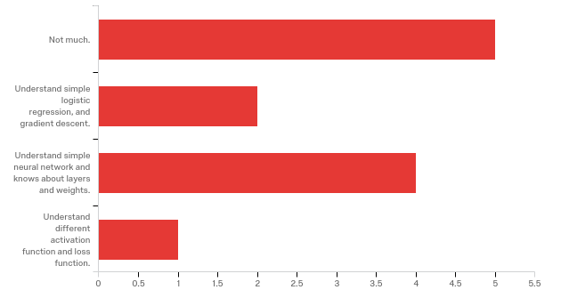

|  |  |  |  |
| --- | --- | --- | --- |
| # | Answer | % | Count |
| 1 | Not much. | 41.67% | 5 |
| 2 | Understand simple logistic regression, and gradient descent. | 16.67% | 2 |
| 3 | Understand simple neural network and knows about layers and weights. | 33.33% | 4 |
| 4 | Understand different activation function and loss function. | 8.33% | 1 |
|  | Total | 100% | 12 |

**Q2 - Section 2, home page(Answer after viewing home page) Describe the goal of the project:**

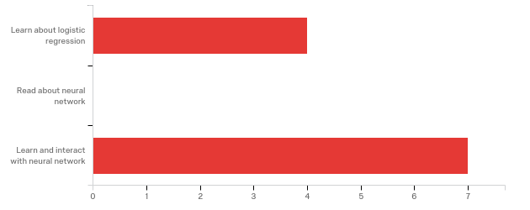

|  |  |  |  |
| --- | --- | --- | --- |
| # | Answer | % | Count |
| 1 | Learn about logistic regression | 36.36% | 4 |
| 2 | Read about neural network | 0.00% | 0 |
| 3 | Learn and interact with neural network | 63.64% | 7 |
|  | Total | 100% | 11 |

**Q4 - Section 3, learn page(Answer after viewing learn page) What are the inputs and output of the toy example?**

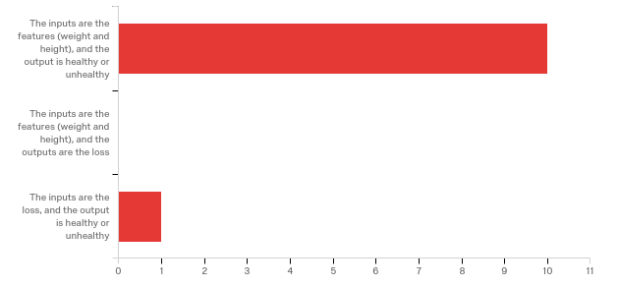

|  |  |  |  |
| --- | --- | --- | --- |
| # | Answer | % | Count |
| 1 | The inputs are the features (weight and height), and the output is healthy or unhealthy | 90.91% | 10 |
| 2 | The inputs are the features (weight and height), and the outputs are the loss | 0.00% | 0 |
| 3 | The inputs are the loss, and the output is healthy or unhealthy | 9.09% | 1 |
|  | Total | 100% | 11 |

**Q5 - What are model parameters?**

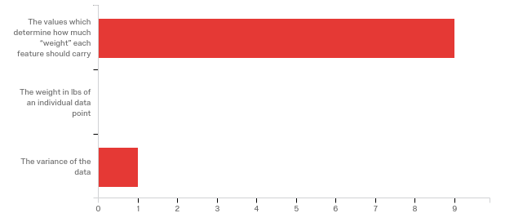

|  |  |  |  |
| --- | --- | --- | --- |
| # | Answer | % | Count |
| 1 | The values which determine how much “weight” each feature should carry | 90.00% | 9 |
| 2 | The weight in lbs of an individual data point | 0.00% | 0 |
| 3 | The variance of the data | 10.00% | 1 |
|  | Total | 100% | 10 |

**Q6 - What question will a trained model be able to answer in the toy example?**

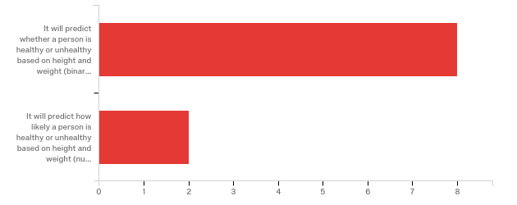

|  |  |  |  |
| --- | --- | --- | --- |
| # | Answer | % | Count |
| 1 | It will predict whether a person is healthy or unhealthy based on height and weight (binary output) | 80.00% | 8 |
| 2 | It will predict how likely a person is healthy or unhealthy based on height and weight (numeric output) | 20.00% | 2 |
|  | Total | 100% | 10 |

**Q7 - How many phases are in the learning of a neural network?**

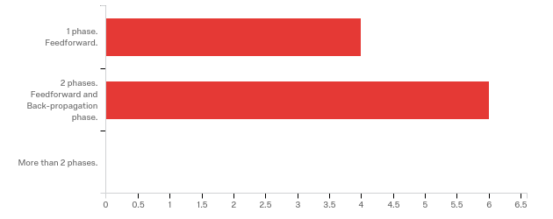

|  |  |  |  |
| --- | --- | --- | --- |
| # | Answer | % | Count |
| 4 | 1 phase. Feedforward. | 40.00% | 4 |
| 5 | 2 phases. Feedforward and Back-propagation phase. | 60.00% | 6 |
| 6 | More than 2 phases. | 0.00% | 0 |
|  | Total | 100% | 10 |

**Q8 - Why is simple logistic regression no longer suitable when “tall skinny guys” show up?**

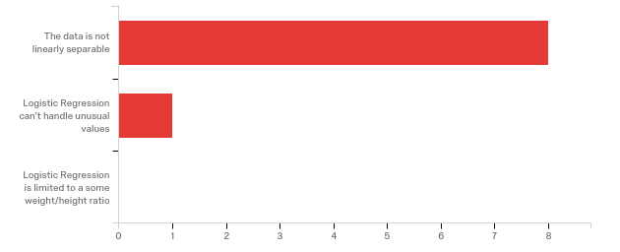

|  |  |  |  |
| --- | --- | --- | --- |
| # | Answer | % | Count |
| 1 | The data is not linearly separable | 88.89% | 8 |
| 2 | Logistic Regression can’t handle unusual values | 11.11% | 1 |
| 3 | Logistic Regression is limited to a some weight/height ratio | 0.00% | 0 |
|  | Total | 100% | 9 |

**Q9 - What does the loss chart show?**

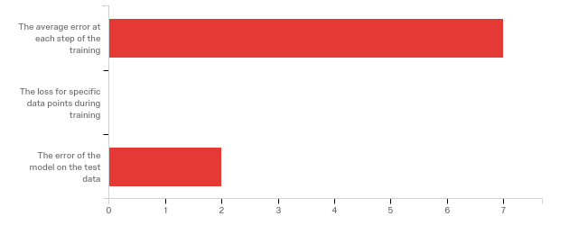

|  |  |  |  |
| --- | --- | --- | --- |
| # | Answer | % | Count |
| 1 | The average error at each step of the training | 77.78% | 7 |
| 2 | The loss for specific data points during training | 0.00% | 0 |
| 3 | The error of the model on the test data | 22.22% | 2 |
|  | Total | 100% | 9 |

**Q10 - What does the gradient descent chart show?**

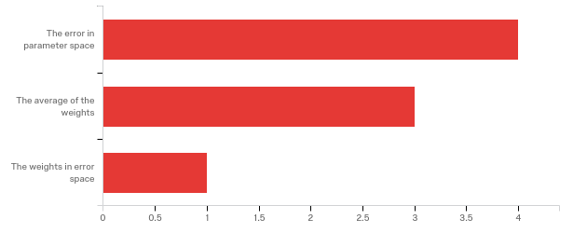

|  |  |  |  |
| --- | --- | --- | --- |
| # | Answer | % | Count |
| 1 | The error in parameter space | 50.00% | 4 |
| 4 | The average of the weights | 37.50% | 3 |
| 3 | The weights in error space | 12.50% | 1 |
|  | Total | 100% | 8 |

**Q11 - Why is the hyperplane different between logistic regression and single layer neural network?**

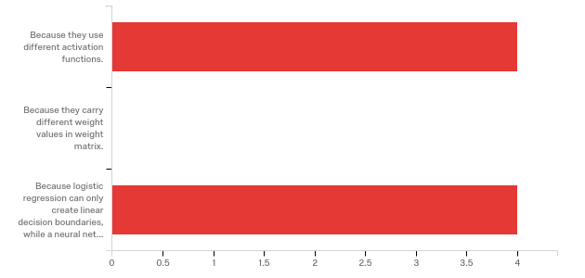

|  |  |  |  |
| --- | --- | --- | --- |
| # | Answer | % | Count |
| 1 | Because they use different activation functions. | 50.00% | 4 |
| 2 | Because they carry different weight values in weight matrix. | 0.00% | 0 |
| 3 | Because logistic regression can only create linear decision boundaries, while a neural network with hidden layers is capable of creating non-linear decision boundaries | 50.00% | 4 |
|  | Total | 100% | 8 |

**Q13 - Section 4, play page(Answer after viewing play page, and build a model with two layers with 10 nodes each) What is the training loss?**

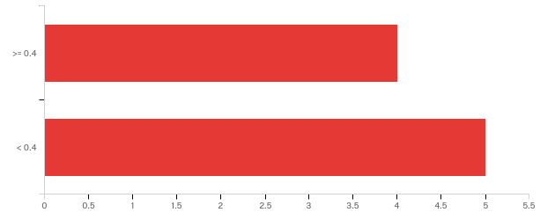

|  |  |  |  |
| --- | --- | --- | --- |
| # | Answer | % | Count |
| 1 | >= 0.4 | 44.44% | 4 |
| 2 | < 0.4 | 55.56% | 5 |
|  | Total | 100% | 9 |

**Q14 - What is the test loss?**

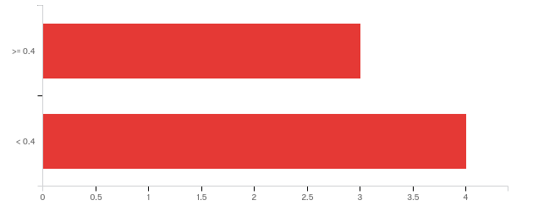

|  |  |  |  |
| --- | --- | --- | --- |
| # | Answer | % | Count |
| 1 | >= 0.4 | 42.86% | 3 |
| 2 | < 0.4 | 57.14% | 4 |
|  | Total | 100% | 7 |

**Q15 - What information to the tooltips on the matrices provide?**

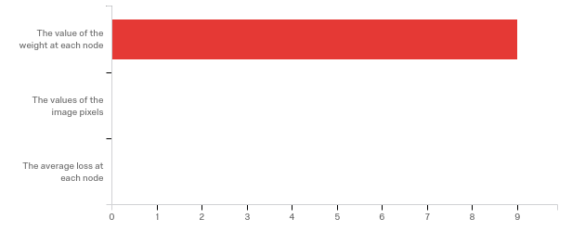

|  |  |  |  |
| --- | --- | --- | --- |
| # | Answer | % | Count |
| 1 | The value of the weight at each node | 100.00% | 9 |
| 2 | The values of the image pixels | 0.00% | 0 |
| 3 | The average loss at each node | 0.00% | 0 |
|  | Total | 100% | 9 |

**Q16 - Where on the page are the model parameters?**

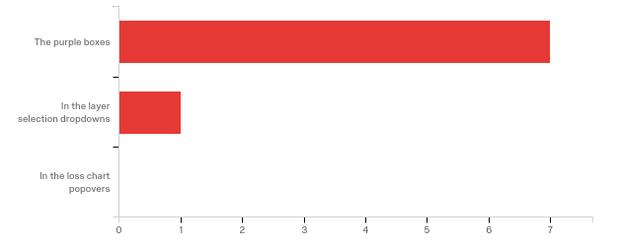

|  |  |  |  |
| --- | --- | --- | --- |
| # | Answer | % | Count |
| 1 | The purple boxes | 87.50% | 7 |
| 2 | In the layer selection dropdowns | 12.50% | 1 |
| 4 | In the loss chart popovers | 0.00% | 0 |
|  | Total | 100% | 8 |

**Q17 - Section 5, LR;DR page (too long didn't read lol)(Answer after viewing LR;DR page) Is this section helpful?**

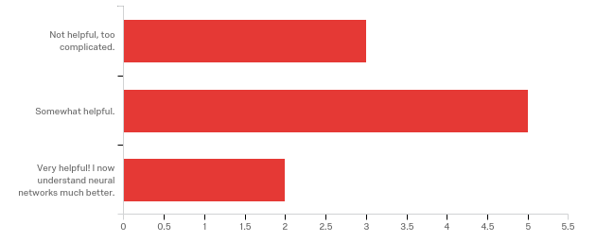

|  |  |  |  |
| --- | --- | --- | --- |
| # | Answer | % | Count |
| 1 | Not helpful, too complicated. | 30.00% | 3 |
| 2 | Somewhat helpful. | 50.00% | 5 |
| 3 | Very helpful! I now understand neural networks much better. | 20.00% | 2 |
|  | Total | 100% | 10 |

**Q18 - Section 6, overall site experience(Last section) Did you learn anything new by using this project?**

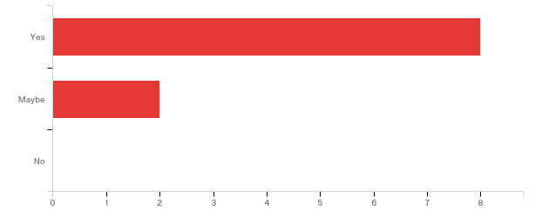

|  |  |  |  |
| --- | --- | --- | --- |
| # | Answer | % | Count |
| 1 | Yes | 80.00% | 8 |
| 2 | Maybe | 20.00% | 2 |
| 3 | No | 0.00% | 0 |
|  | Total | 100% | 10 |

**Q19 - Did this project help you get some insight into the mechanics of NNs?**

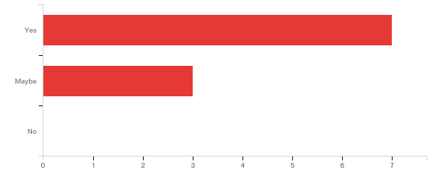

|  |  |  |  |
| --- | --- | --- | --- |
| # | Answer | % | Count |
| 1 | Yes | 70.00% | 7 |
| 2 | Maybe | 30.00% | 3 |
| 3 | No | 0.00% | 0 |
|  | Total | 100% | 10 |

**Q20 - Was there anything particularly frustrating or unclear?**

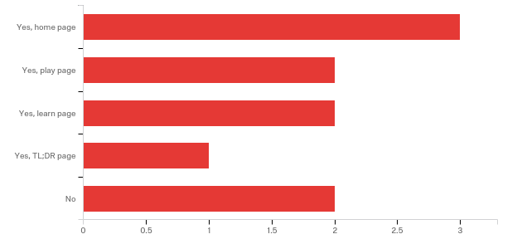

|  |  |  |  |
| --- | --- | --- | --- |
| # | Answer | % | Count |
| 1 | Yes, home page | 30.00% | 3 |
| 2 | Yes, play page | 20.00% | 2 |
| 4 | Yes, learn page | 20.00% | 2 |
| 5 | Yes, TL;DR page | 10.00% | 1 |
| 3 | No | 20.00% | 2 |
|  | Total | 100% | 10 |

**Q21 - What did you like best?**

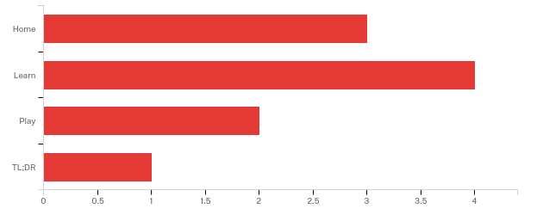

|  |  |  |  |
| --- | --- | --- | --- |
| # | Answer | % | Count |
| 1 | Home | 30.00% | 3 |
| 2 | Learn | 40.00% | 4 |
| 3 | Play | 20.00% | 2 |
| 4 | TL;DR | 10.00% | 1 |
|  | Total | 100% | 10 |